File
The “File” option is available for your convenience throughout each application.

To save a file, click the File button. The following window will appear (the “Save As” window may vary in appearance):

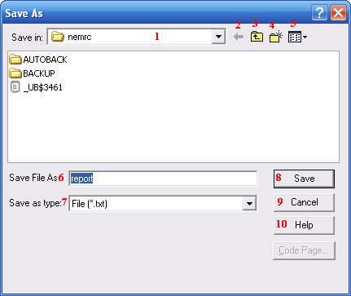
- Save in: Click on the drop down arrow to select the location/folder where you wish to save your file.

- Click the “arrow” button to go back to the previous folder.

- Click to go “up” a level in the folder list.

- Click to create a new folder in the selected location. Enter the name of the folder and hit “enter” on your keyboard.

- Click to select a different list option.

- Save File As: Enter your name for the report/file/export.

- Save as type: Enter type of file for report/file/export. You may click the drop down arrow for a list of file type choices. The most frequently used file type, for this option, is “File (*.txt).”

- Save: Click “Save” to save the file to the location/folder indicated and close the window.

- Cancel: Click “Cancel” to close the window without saving.

- Help: Click “Help” for additional assistance with saving files.

